Process Management Tool
and
Process Engine

V. 2

Installation Guide

 | NamE | partner | Date
Written by
Reviewed by

Record of Revisions
Issue | Date | Effect on |  | Reasons For Revision
 |  | Page | Para

Table of contents
1. Introduction 6
1.1 Goal of this document 6
1.2 Galaxy Server achitecture overview 6
2. Prerequisite 6
3. COTS 6
3.1 JBoss installation 6
3.2 H2 installation 6
4. Configuration 6
4.1 Configure Datasource 6
4.2 Test JBoss installation 7
5. Deployment 7
6. Database Configuration 9
6.1 H2 managing 9
7. Test PMTool Editor 9

TABLE OF FIGURES

No table of figures entries found.

Table of APPLICABLE DOCUMENTS
N° | title | Reference | Issue | Date | Source
 |  |  |  |  | Siglum | Name

Table of ReferenceD DOCUMENTS
N° | title | Reference | Issue

ACRONYMS AND DEFINITIONS

Except if explicitly stated otherwise the definition of all terms and acronyms provided in [R2] is applicable in this document. If any, additional and/or specific definitions applicable only in this document are listed in the two tables below.
Acronyms
Acronym | DESCRIPTION
Definitions
TERMS | DESCRIPTION

Introduction

Goal of this document
This document aims to describe the installation procedure of the Process Engine server application and the Process Management Tool Editor.

Galaxy Server achitecture overview
TODO

Prerequisite
The implementation of both client (Process Management Tool Editor) and server (Process Engine) applications are based on the Java programming language and need the Java Development Kit version 1.6 update 23 to be installed.
Double click on jdk-6u23-windows-i586.exe located in the COTS folder and follows instructions in order to install it.

COTS
This part describes the installation of software needed to run the Process Engine server.

JBoss installation
The Process Engine server application has been developed on the JBOSS server available in the COTS folder.

- Unzip jboss-as-7.x.zip in its installation directory (we will call it [JBOSS-INSTALL-DIRECTORY]).
- Create an environment variable named JBOSS_HOME locating the [JBOSS-INSTALL-DIRECTORY] folder.
- Execute the [JBOSS-INSTALL-DIRECTORY]/bin/add-user.bat batch file and follow instructions in order to create a user to access the Administration Console.

H2 installation
The Process Engine server repository is based on H2 database embedded in JBOSS.

Configuration
This part gives a description of the configuration of H2.

Configure Datasource
- Edit the standalone-full.xml file located into [JBOSS_INSTALL_DIRECTORY]/standalone/configuration and add the following code between the tags <datasources> :
<datasource jndi-name="java:/ProcessEngineDS" pool-name="ProcessEngineDS" enabled="true" use-java-context="true">
<connection-url>jdbc:h2:tcp://localhost/processEngine</connection-url>
<driver>h2</driver>
<security>
<user-name>sa</user-name>
<password>sa</password>
</security>
</datasource>

Test JBoss installation
- Start JBOSS server by executing the [JBOSS_INSTALL_DIRECTORY]/bin/standalone.bat batch file with the following arguments:
  - --server-config=standalone-full.xml
  - -b 0.0.0.0
The first argument tells JBOSS to use the standalone-full.xml file previously modified.
The second argument force JBOSS to accept remote connection.

- Open a browser and access to JBOSS administration main page with the address : http://[SERVER-IP-ADDRESS]:8080 where [SERVER-IP-ADDRESS] represents the IP address of the server where JBOSS has been installed.
If you should see the page below, the JBoss application server is running.

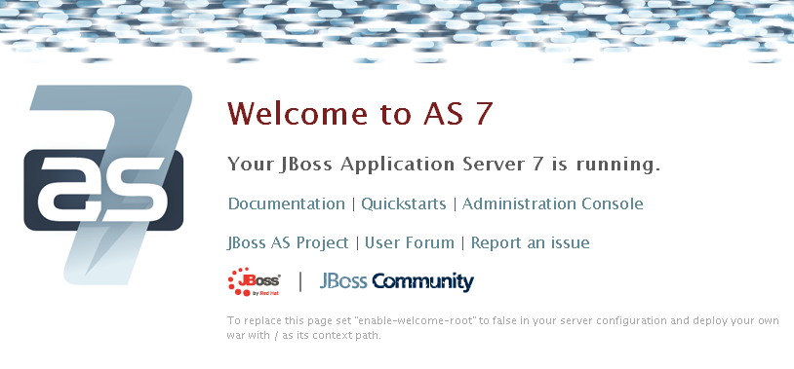

Deployment
Here we are going to explain how to deploy the Process Engine server application.

- From the server where JBOSS has been installed, open a browser and access to JBOSS administration page (§ 4.4)
- Click on the Administration Console html link and specify the username and the password entered during user creation process (§ 3.1)
- In the JBOSS Administration Console, choose Runtime tab then choose Manage Deployments under the Deployments item menu on the left and click on the Add Content button.

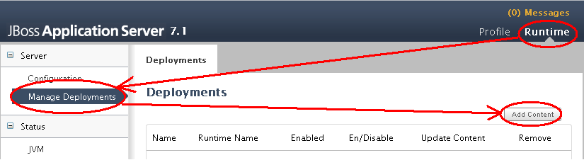

- In the dialog box, click the Browse... button, select the process-engine.war file located into the ProcessEngine folder then click on Next.

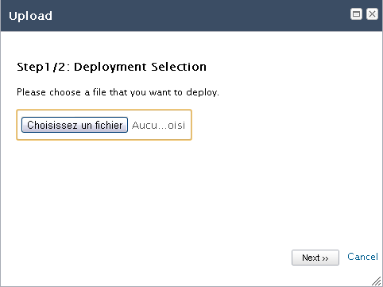

- Click on the Save button.

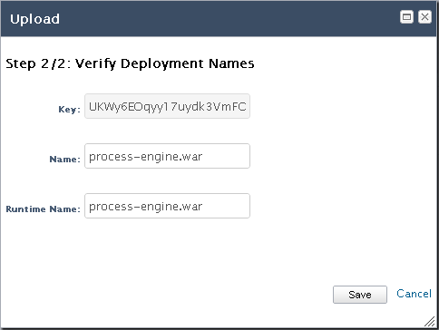

- You should now see the web archive file listed in the Deployments table :

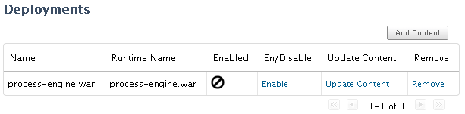

- Click on the Enable button and confirm you want to enable process-engine.war.

You should see a message in the Administration Console confirming the deployment has been done successfully. You can also see the result of this deployment in the console where JBOSS has been started.

Database Configuration

H2 managing
Jboss provides a GUI to manage H2 databases. To launch it, double-clic on the jar file :
[JBOSS-INSTALL-DIRECTORY]\modules\com\h2database\h2\main\h2-1.3.168.jar

Test PMTool Editor

